TVAC/Wessex NewstrAid Walk
Sunday April19th

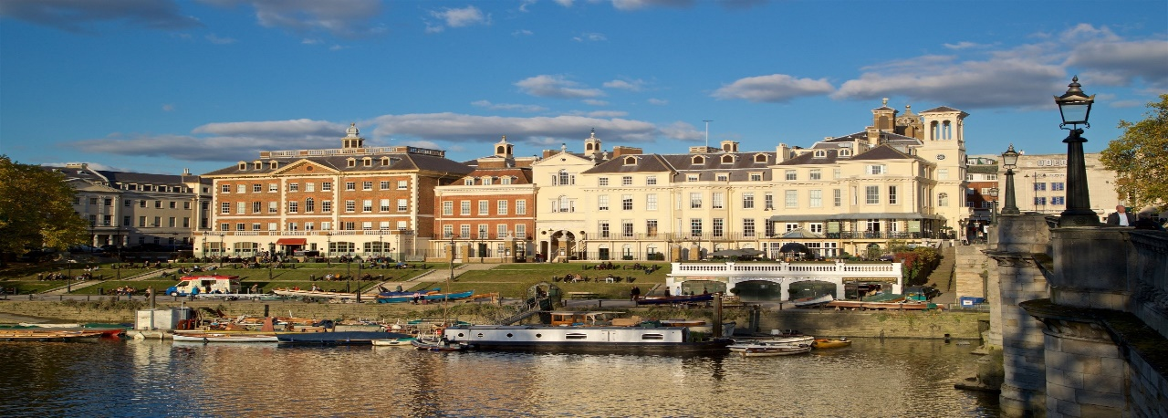
Schedule of the walk

Dogs Welcome
Children Welcome
Flat Terrain
4.5 miles
Free Car Parking

Sponsorship

Each Walker will donate £10.00 to NewstrAid (over 18)
This will be collected on the day (Gift Aid Document will be provided)

Outward

Meeting Place Twickenham Bridge Ranelagh Drive TW1 1QZ (meet 10.30am) Start 11.00am

Ducks Walk/Marble House Park/Orleans Gallery/York House Gardens/Eel Pie Island

Eel Pie Pub (Lunch) 1.30pm (Lunch in function room of the pub.)

Food will be preordered before the event. (Menus to be circulated nearer the time.)

Inward

Hammerton’s Ferry (Optional)
This involves going across the Thames on a small boat and walking back to Richmond on the other side of the Thames. This costs an Additional £2.00 cash

Twickenham Bridge

Return 3.00pm-4.00pm

